* **Explain** why water is considered to be a polar molecule. **Label** the picture to help with your explanation.

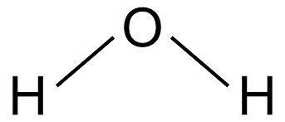

* **Draw** the hydrogen bonds that exist between several water molecules. **Label** partial charges as well!

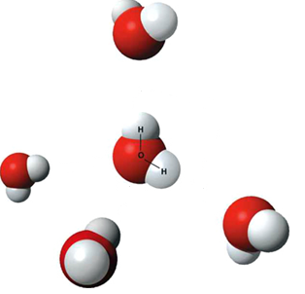

* **Differentiate** between adhesion and cohesion. **Draw** a diagram of and describe how these properties facilitate transpiration (movement of water through a plant).
* **Label** the following diagrams with the following labels:
  + Liquid water
  + Solid water
  + Gaseous water
  + Hottest temperature
  + Coldest temperature
  + Greatest density
  + Lowest density

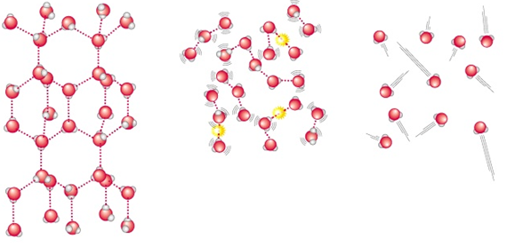

* **Explain** why you have assigned each diagram each of the labels.

**Explain** how hydrogen bonding leads to each of the following properties of water and **describe** the biologically relevant example shown in each picture.

* High surface tension

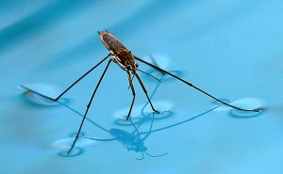

* High specific heat

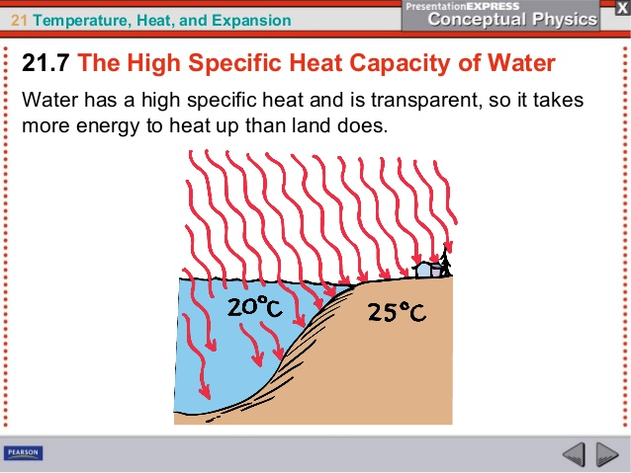

* For each of the following molecules, **identify**/**label** the following key information:
  + Name
  + Function
  + Type of macromolecule
  + Monomer component

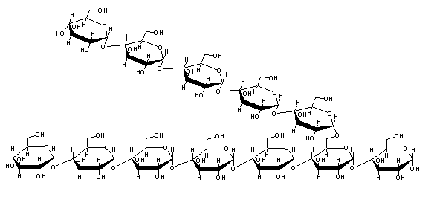

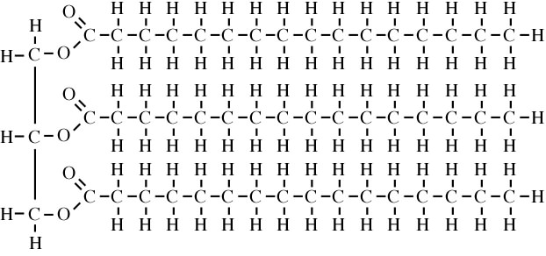

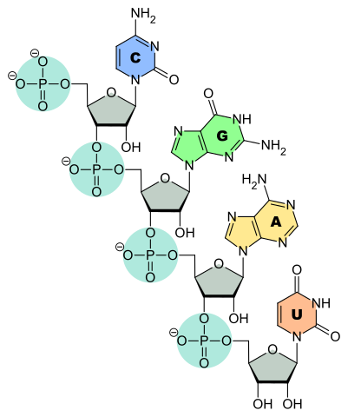

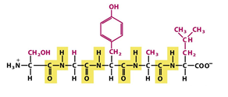

* **Explain** how dehydration synthesis and hydrolysis reactions relate to all of the above macromolecules.

**Draw** the final product that would result if the two monomers went through dehydration synthesis.

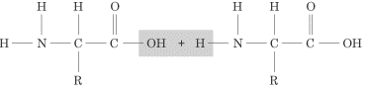

**Draw** the final products that would result if the polymer went through hydrolysis.

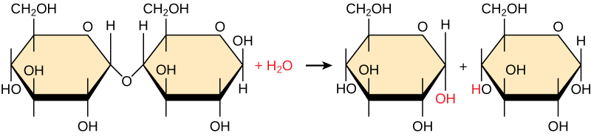

The following diagram shows the nitrogen cycle.

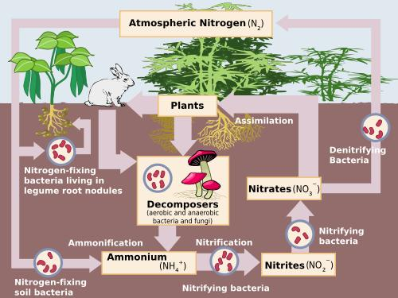

* **Predict** what would happen to a plant’s ability to make macromolecules if they were deprived of a source of nitrogen? **Justify** your answer.

The following diagram shows the phosphorus cycle.

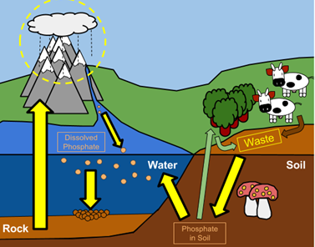

* **Predict** what would happen to a plant’s ability to make macromolecules if they were deprived of a source of phosphorus? **Justify** your answer.

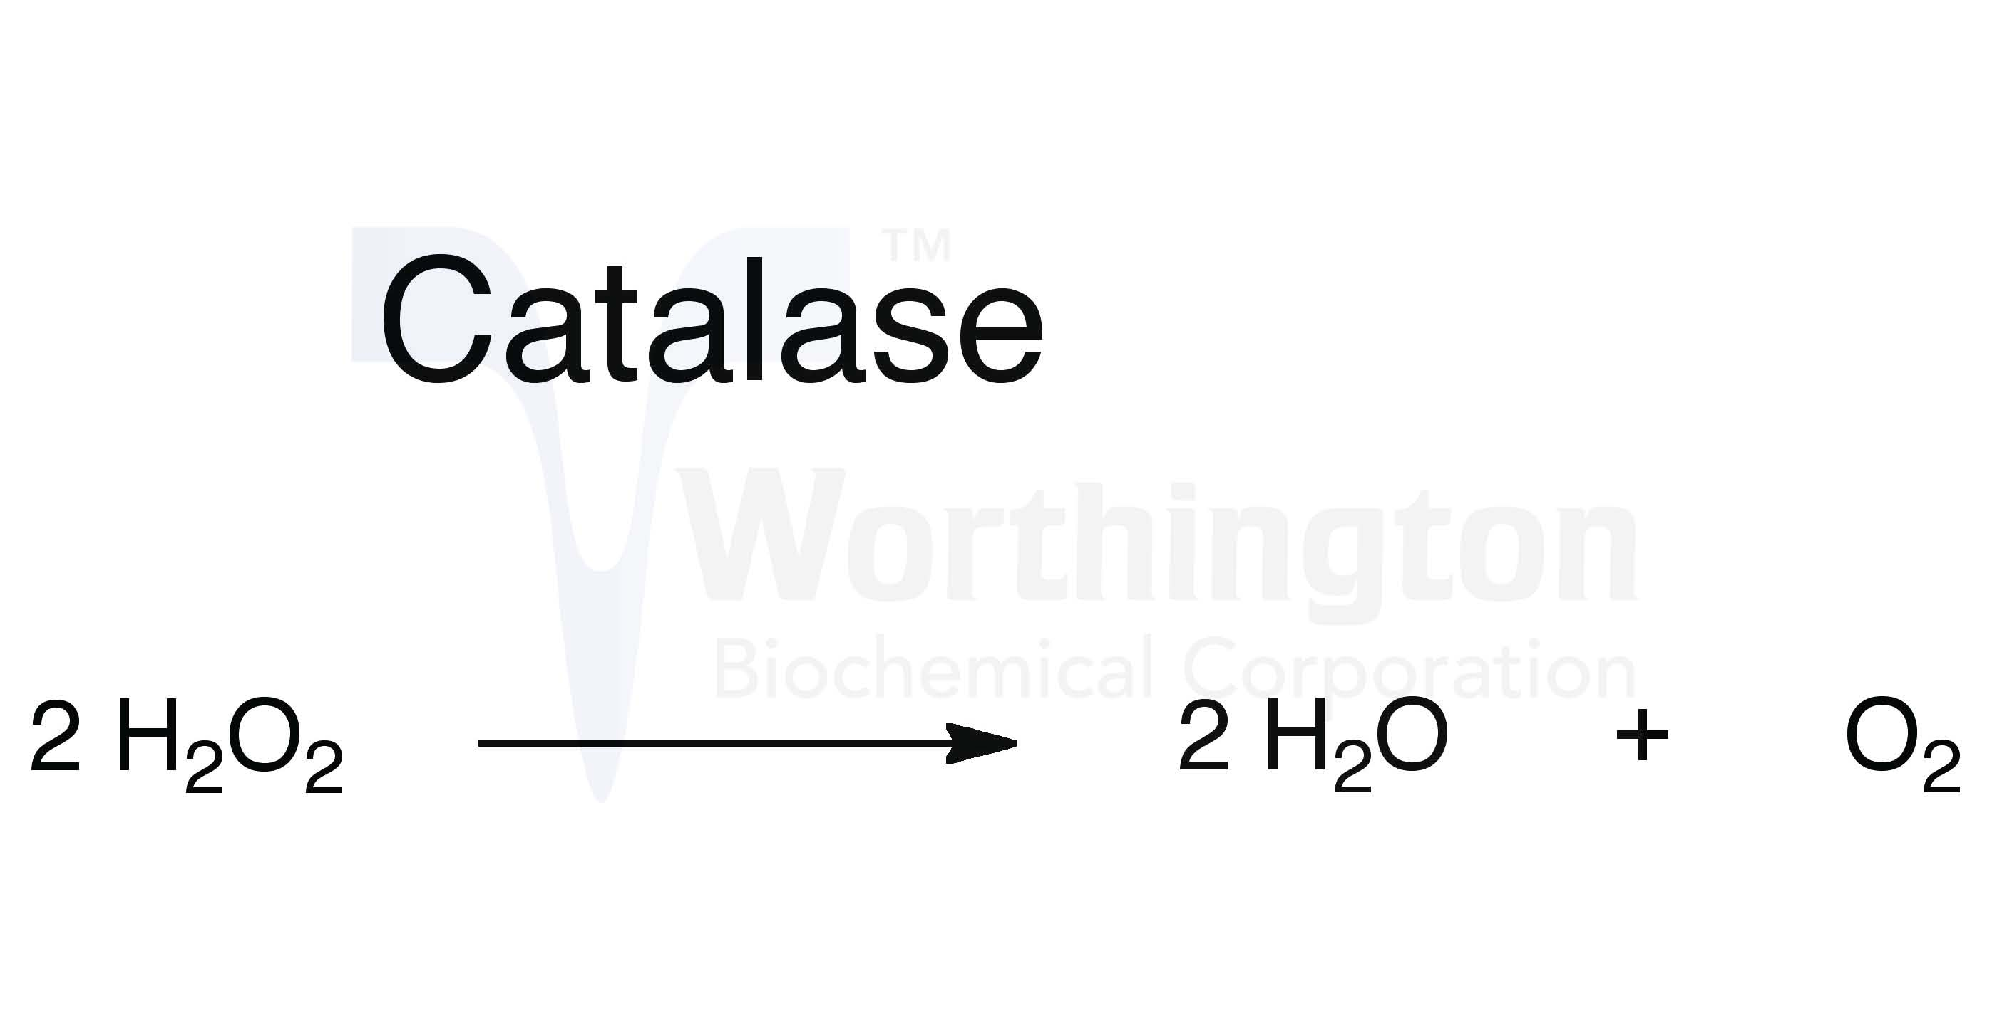

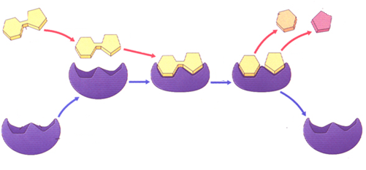

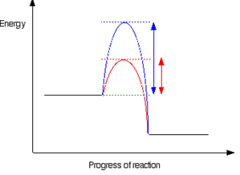

* **Explain** how the chemical equation, diagram, and graph are related to one another. **Label** everything you can!
* You isolate an enzyme that hydrolyzes lipid in the human small intestine where normal pH is 7-8 and the temperature is about 37°C. **Predict** what would occur to the reaction rate when placed under the following conditions and **explain** your reasoning.
  1. Triple the concentration of the enzyme
  2. Decrease temperature to 25°C
  3. Decrease the concentration of the substrate
  4. Increase temperature to 100 °C
  5. How would the rates of lipid hydrolysis compare in the human intestine if a person ate a hamburger verses a dry bowl of whole-wheat cereal?

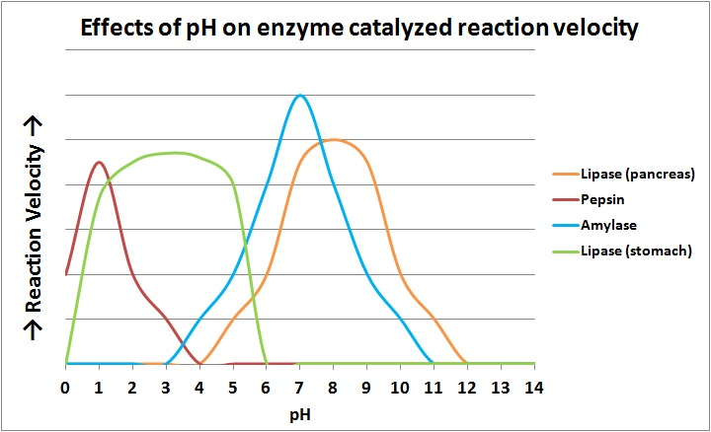

* **Contrast** the optimal pH for each of the above enzymes. **Rank** them in order from most acidic optimal pH to most alkaline.

1. **Predict** what would happen to pancreatic lipase if it were dropped into a solution where pH=3?
2. **Predict** what would happen to stomach lipase if it were dropped into a solution where pH=8.5?